

|  |  |  |  |  |  |
| --- | --- | --- | --- | --- | --- |
| Programme | : | **M.Tech. (Integrated) Software Engineering** | Semester | : | **Fall 20-21** |
| Course | : | **Advanced Database Management Systems** | Code | : | **SWE2014** |
| Faculty | : | **Dr.Bhuvaneswari A** | Slot | : | **L44 + L45** |
| Date | : | **15-09-2020** | Marks | : | **10 Points** |
|  |  |  |  |  |  |

# 

# **KANDULA NAVEEN KUMAR**

# **17MIS1056**

# Ex No. 8 TEMPORAL DATABASE USING ORACLE

CREATE TABLES

SQL> CREATE TABLE CUSTOMER (

CUST_ID NUMBER(10) PRIMARY KEY,

CUST_NAME VARCHAR2(30) NOT NULL, DOB DATE NOT NULL,

CONTACT_NO NUMBER(10) NOT NULL,

);

Table created.

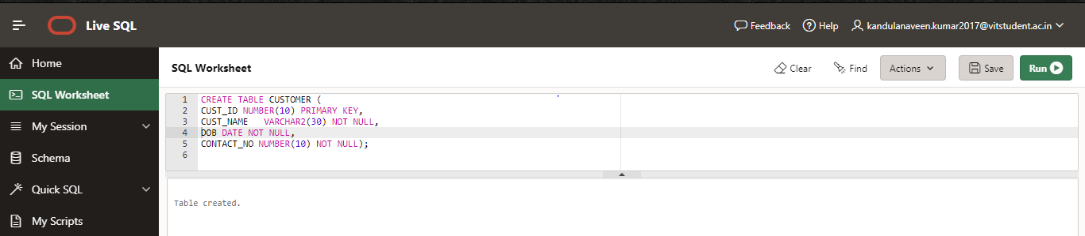

SQL> CREATE TABLE DTH_PACKAGE (

PACKAGE_ID NUMBER(10) PRIMARY KEY, PACKAGE_NAME VARCHAR2(20) NOT NULL, PACKAGE_RENT NUMBER(10,2) NOT NULL

);

Table created.

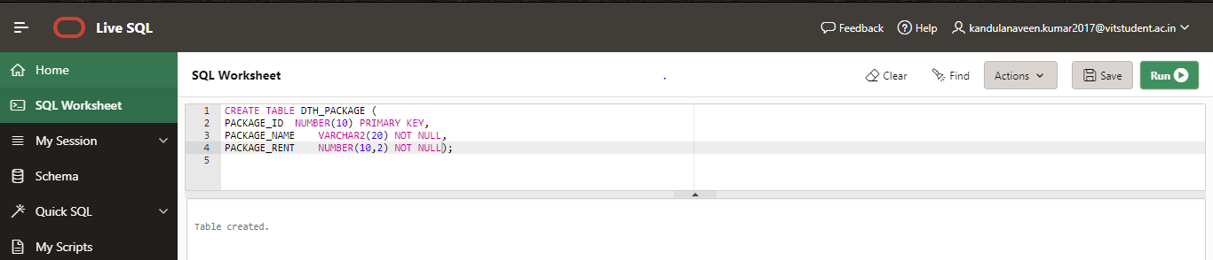

SQL> CREATE TABLE CUSTOMER_PACKAGE (

ID NUMBER(10) PRIMARY KEY,

CUST_ID NUMBER(10) REFERENCES CUSTOMER(CUST_ID), PACKAGE_ID NUMBER(10) REFERENCES DTH_PACKAGE(PACKAGE_ID), START_DATE DATE,

END_DATE DATE,

PERIOD FOR customer_package_period (START_DATE,END_DATE)

);

Table created.

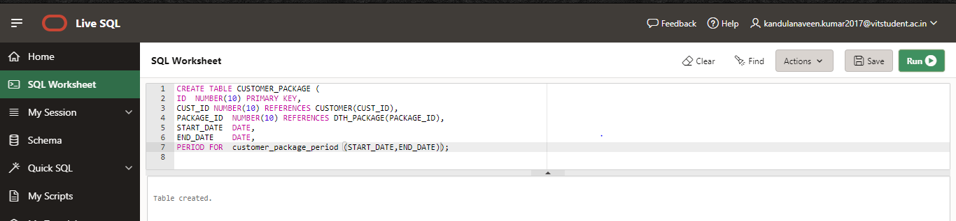

INSERT ALL VALUES INTO TABLE SQL> SELECT * FROM CUSTOMER;

CUST_ID CUST_NAME CONTACT_NO DOB

|  |  |  |  |  |  |
| --- | --- | --- | --- | --- | --- |
| 1 | AMAR | 5674889923 |  |  | 20-JUN-1988 |
| 2 | BHAVESH | 4468975213 |  |  | 11-AUG-1998 |
| 3 | CHAITALI | 3232158872 |  |  | 16-SEP-2000 |
| 4 | DISHA | 5567821346 |  |  | 13-NOV-1992 |
| 5 | RIO | 9998888888 |  |  | 27-JAN-1999 |
| 6 | SUJA | 0999911111 |  |  | 19-MAY-1986 |

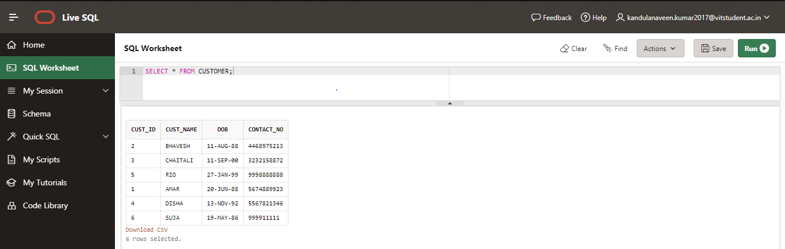

SQL> SELECT * FROM DTH_PACKAGE;

PACKAGE_ID PACKAGE_NAME PACKAGE_RENT

|  |  |  |
| --- | --- | --- |
| 1 | PLATINUM | 499 |
| 2 | GOLD | 460 |
| 3 | SUPER FAMILY | 335 |

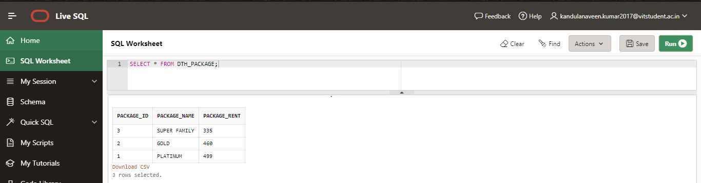

SQL> SELECT * FROM CUSTOMER_PACKAGE;

ID CUST_ID PACKAGE_ID START_DAT END_DATE

|  |  |  |  |  |  |  |
| --- | --- | --- | --- | --- | --- | --- |
| 1 | 1 | 1 | 01-JAN-12 |  |  | 10-FEB-12 |
| 2 | 1 | 2 | 01-FEB-12 |  |  | 15-MAR-12 |
| 3 | 1 | 3 | 01-JAN-12 |  |  | 01-APR-12 |
| 4 | 2 | 1 | 01-JAN-12 |  |  | 10-FEB-12 |
| 5 | 2 | 2 | 01-FEB-12 |  |  | 15-MAR-12 |
| 6 | 2 | 3 | 01-JAN-12 |  |  | 01-APR-12 |
| 7 | 3 | 1 | 01-JAN-13 |  |  | 10-FEB-13 |
| 8 | 3 | 2 | 01-FEB-13 |  |  | 15-MAR-13 |
| 9 | 3 | 3 | 01-JAN-13 |  |  | 01-APR-13 |
| 10 | 3 | 3 | 02-APR-13 |  |  | 01-JUL-14 |
| 11 | 4 | 1 | 01-JAN-14 |  |  | 10-FEB-14 |
| 12 | 4 | 2 | 01-FEB-14 |  |  | 15-MAR-14 |
| 13 | 5 | 3 | 01-JAN-14 |  |  | 20-OCT-15 |
| 14 | 1 | 1 | 01-JAN-18 |  |  | 01-APR-19 |
| 15 | 3 | 1 | 01-JAN-17 |  |  | 01-JAN-18 |
| 16 | 4 | 3 | 01-JAN-18 |  |  | 20-OCT-20 |
| 17 | 5 | 1 | 01-JAN-18 |  |  | 20-OCT-20 |
| 18 | 6 | 1 | 01-OCT-18 |  |  | 12-OCT-20 |
|  |  |  |  |  |  |  |
|  |  |  |  |  |  |  |

‘

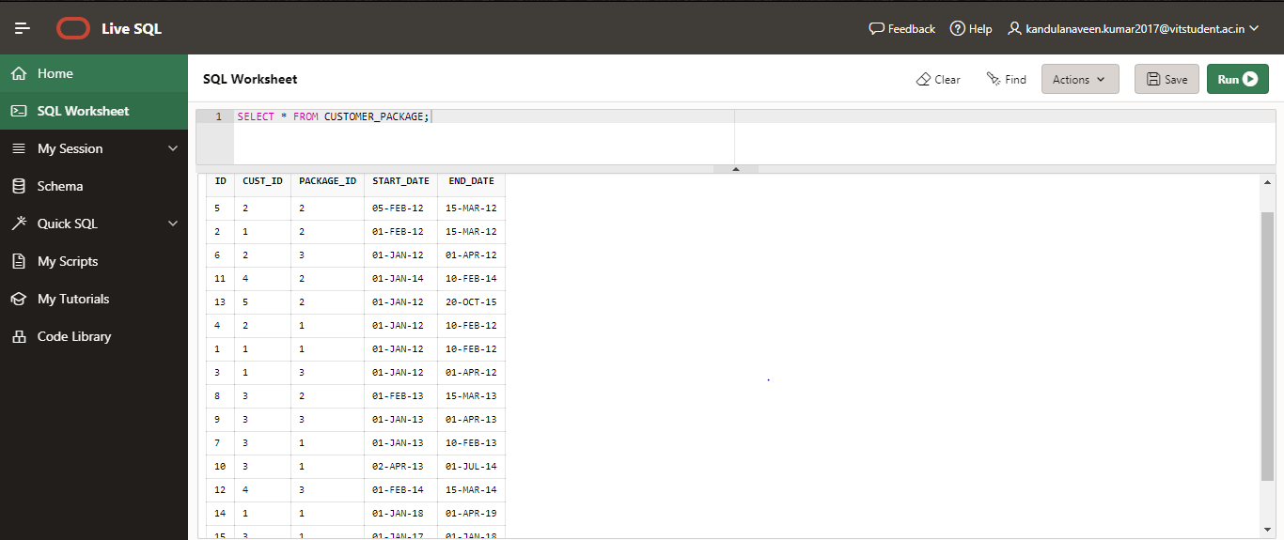

SQL>COMMIT;

Use Oracle SQL to Query the following questions:

1. Find out which customer has subscribed which package on a specific date 22-Mar-2013?

ANS:

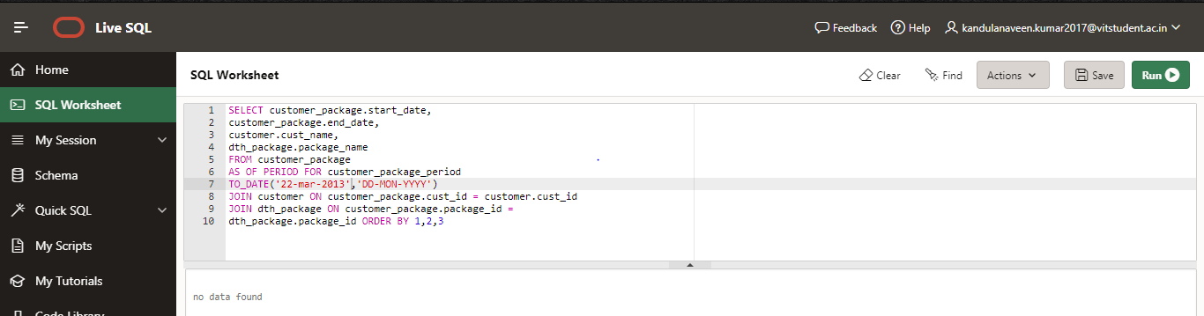

1. Find the customer, FromDate and ToDate who subscribed a DTH package ‘GOLD’

ANS:

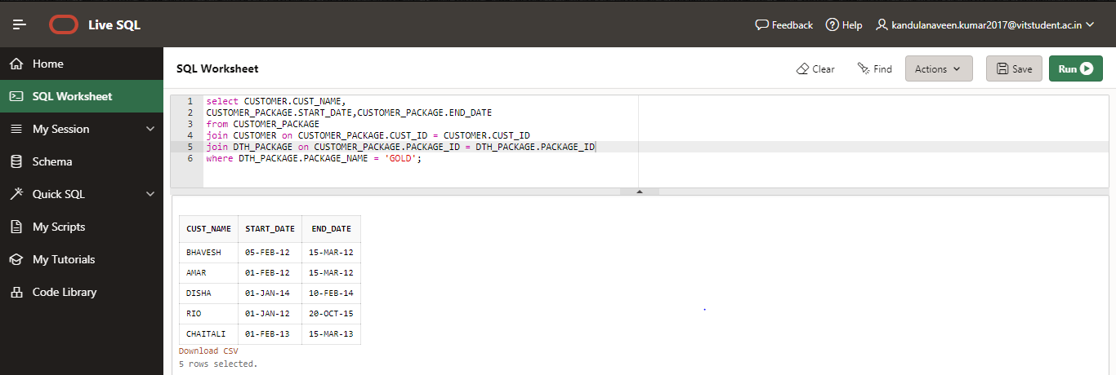

1. Find the name and age of the youngest customer.

ANS:

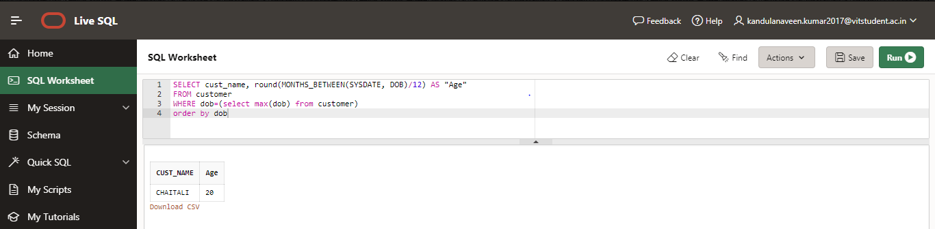

1. Find the name of the customer who born between specific time period i.e. between 22-JAN-1980 and 11- DEC-1989.

ANS:

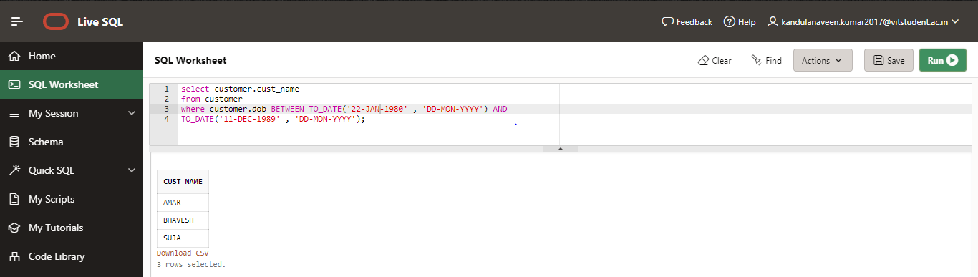

5.Find customers along with their active packages as on today

ANS:

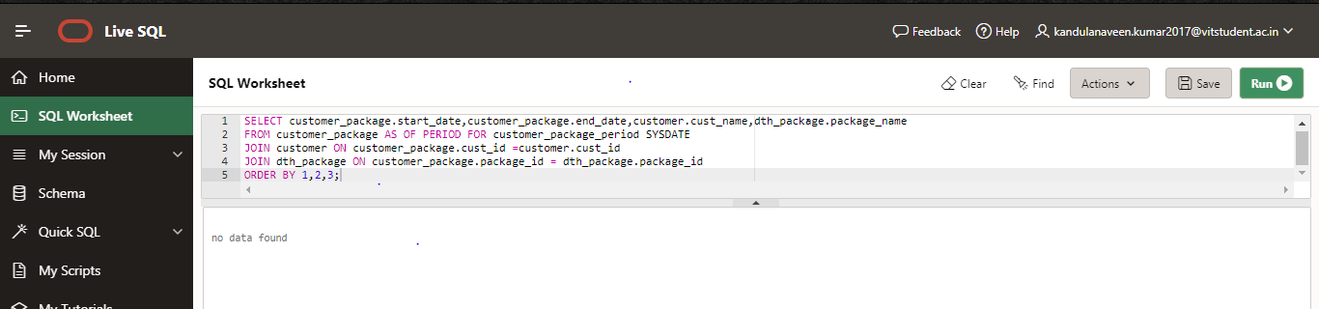

1. Find the number of customers who activated each DTH package till date.

ANS:

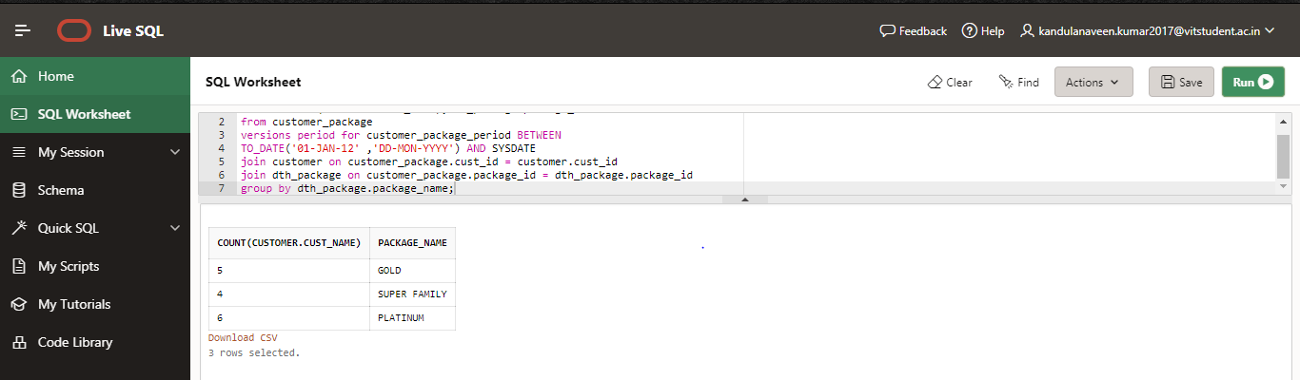

1. Display customer along with their active dth package on a given specific time period i.e. between 22-FEB- 2012 and 11-JAN-2014.

ANS:

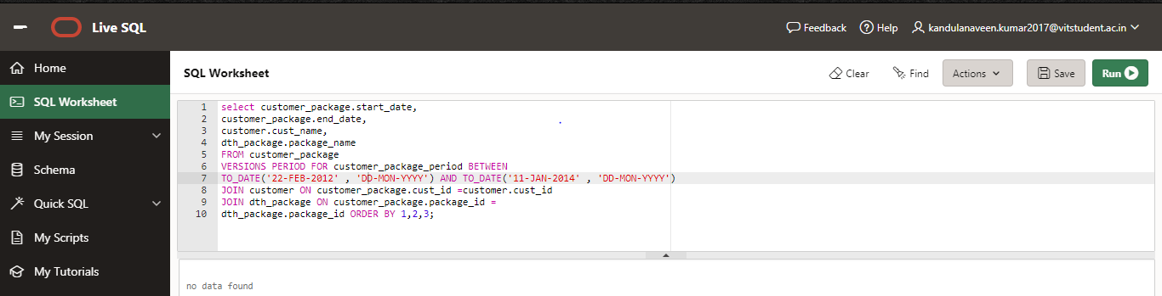

1. Find the customer who subscribed maximum number of DTH packages in given specific time period i.e. between 22-FEB-2013 and 11-DEC-2014.

ANS:

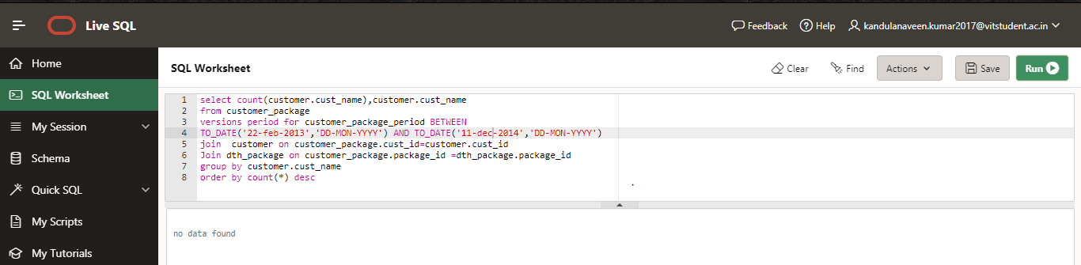

1. Find the customer details who didn’t subscribed any DTH package as on 01-MAR-2018.

ANS:

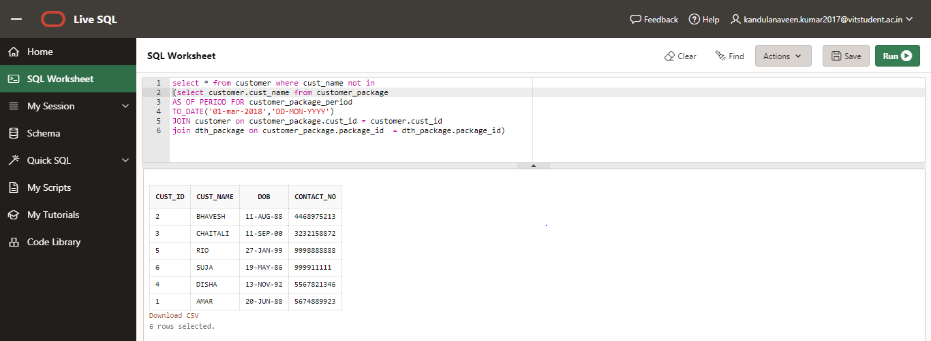

1. Find the customer details who subscribed only ‘PLATINUM’ DTH package and not ‘GOLD’ DTH package.

ANS:

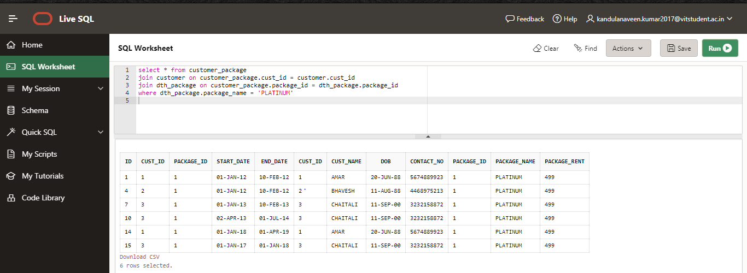

1. Find the customer who subscribed and renewed SUPER FAMILY package twice in the year 2013-2014.

ANS:

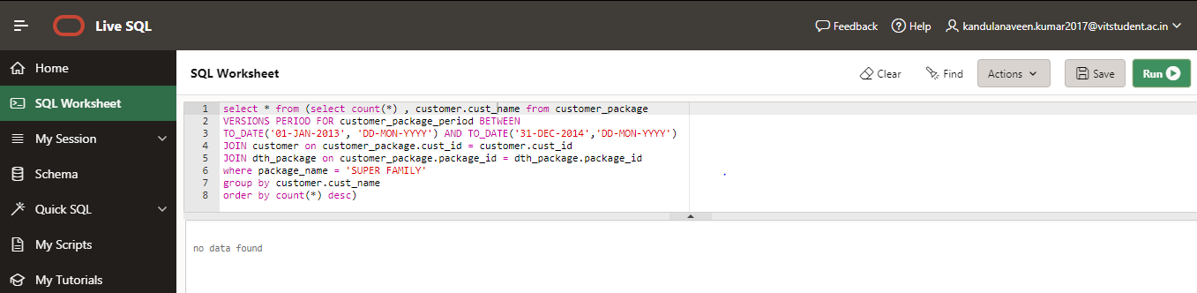

1. Find the top three customers who took PLATINUM subscription package recently in the last 6 months.

ANS:

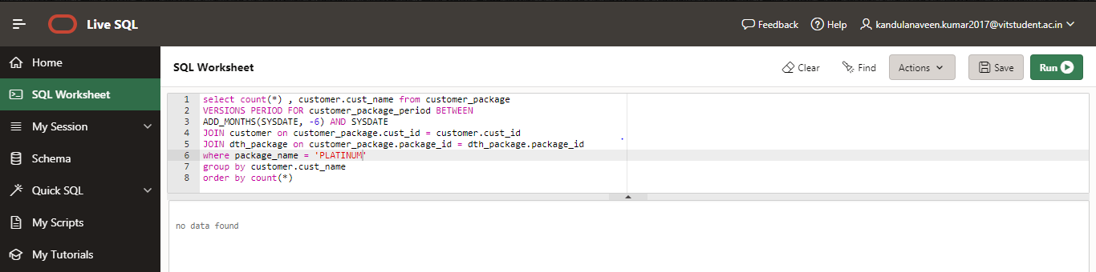

1. Find the customer who subscribed yearly DTH package.

ANS:

